**Shashwat Tripathi**

**D10A 58**

**BATCH: C**

**PYTHON LAB**

**Assignment No: 1**

**Q)** Grading a MCQ test using Multi-dimensional arrays.

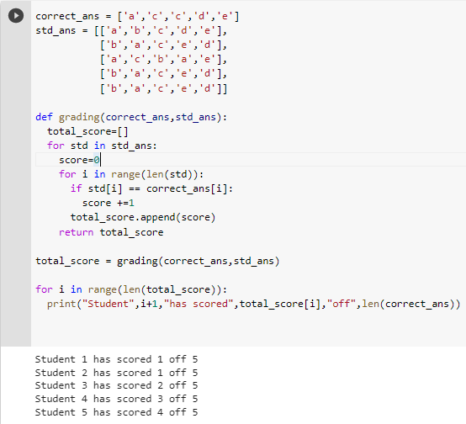

**Shashwat Tripathi**

**D10A 58**

**Batch: C**

**PYTHON LAB**

**Exp No: 1**

**AIM:** Write python programs to understand

a) Basic data types, Operators, expressions and Input Output Statements

b) Control flow statements: Conditional statements (if, if...else, nested if)

c) Looping in Python (while loop, for loop, nested loops)

d) Iterators and Generators.

**PRINT STATEMENT**

Code:

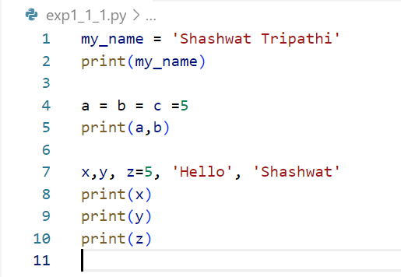

Output:

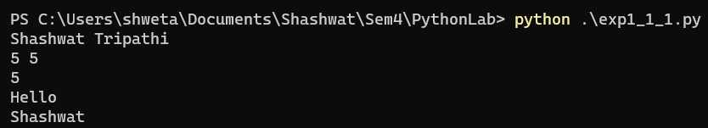

**IDENTIFY TYPES**

Code:

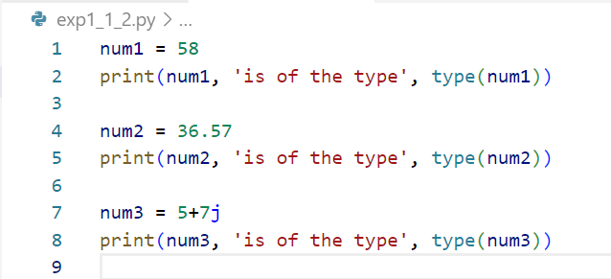

Output:

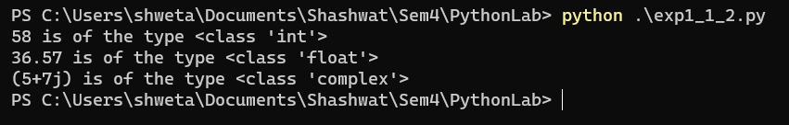

**PRINT DATA OF TYPES**

Code:

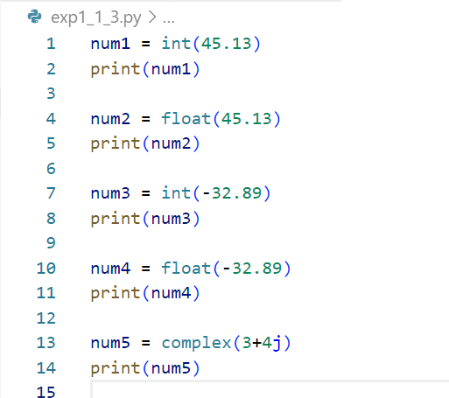

Output:

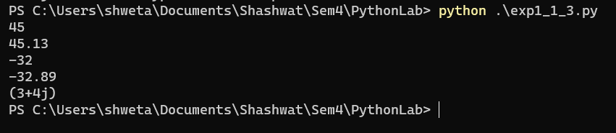

**ADDITION OF TWO NUMBERS**

Code:

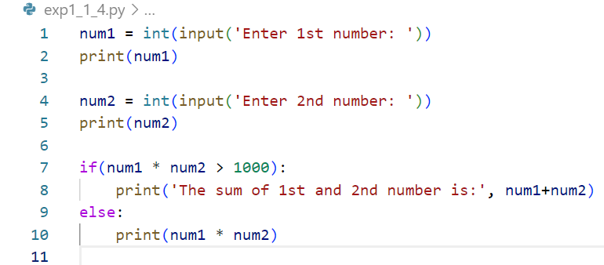

Output:

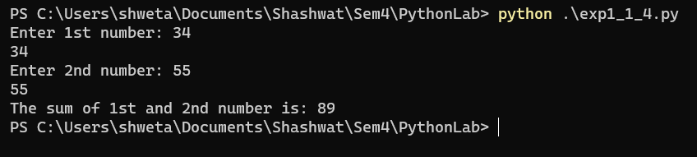

**DATA FROM USER**

Code:

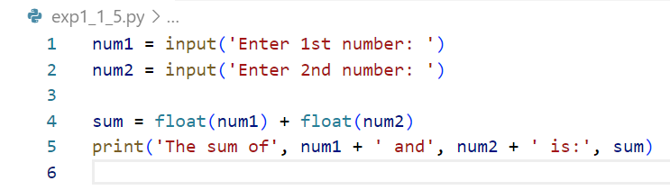

Output:

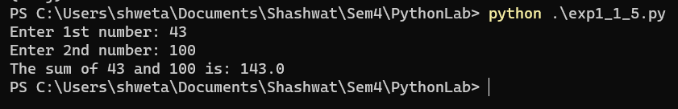

**ARITHMETIC OPERATORS**

Code:

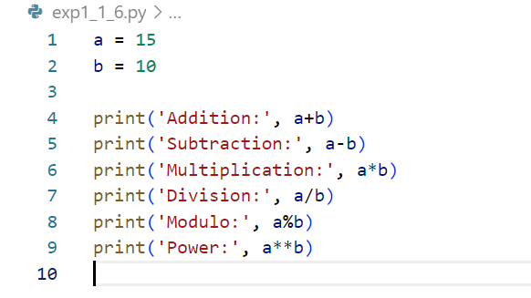

Output:

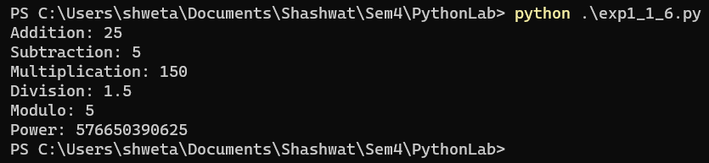

**ASSIGNMENT OPERATORS**

Code:

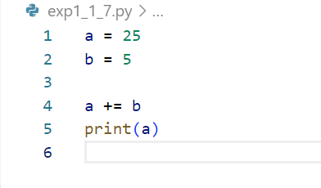

Output:



**COMPARISON OPERATORS**

Code:

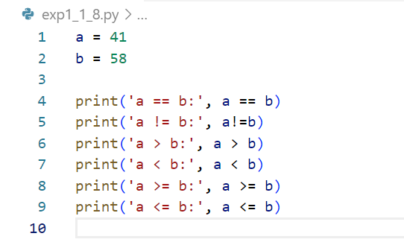

Output:

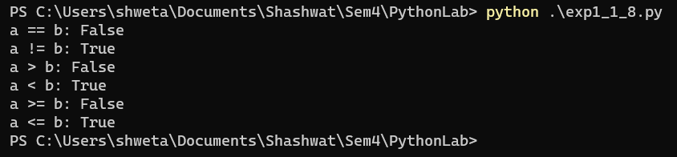

**IDENTITY OPERATOR**

Code:

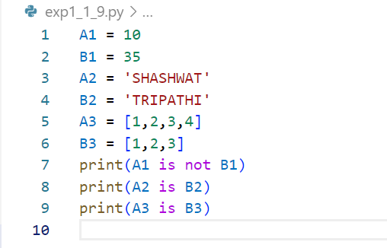

Output:

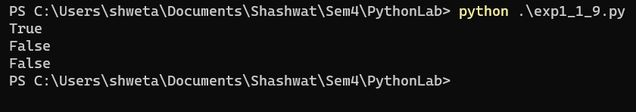

**MEMBERSHIP OPERATOR**

Code:

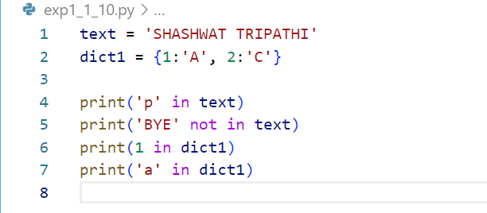

Output:

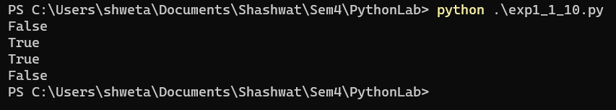

**Conclusion:** The concepts of basic data types, operators, expressions, conditional statements, looping in Python were studied and successfully implemented.

**Shashwat Tripathi**

**D10A 58**

**BATCH: C**

**PYTHON LAB**

**Exp No: 2**

**AIM:** Write python programs to understand

a) Different List and Tuple operations using Built-in functions

b) Built-in Set and String functions

c) Basic Array operations on 1-D and Multidimensional arrays using Numpy

d) Implementing User defined and Anonymous Functions

**A) LIST, TUPLES, DICTIONARY**

**LIST:**

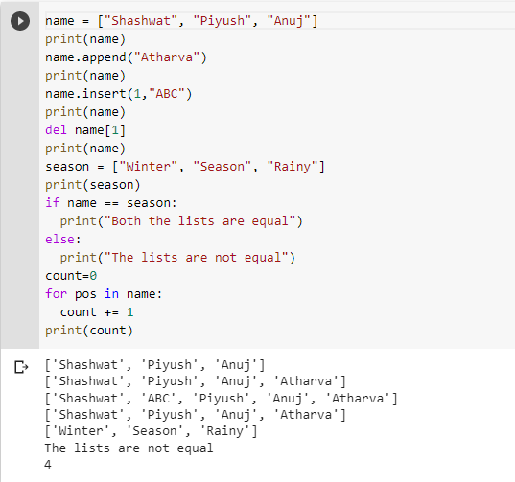

**TUPLE**

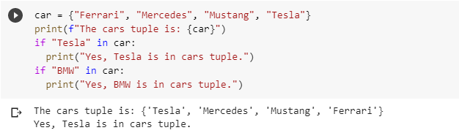

**DICTIONARY**

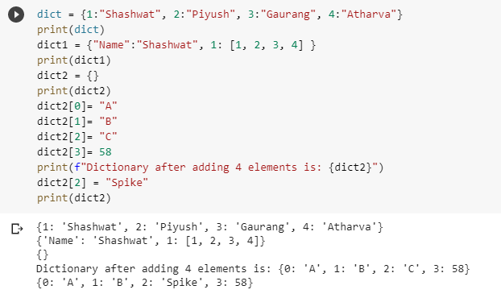

**B) BUILT-IN SET AND STRING FUNCTIONS**

**SETS:-**

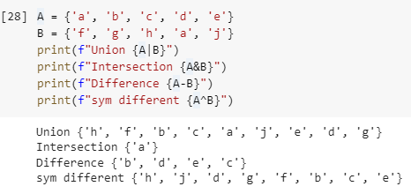

**STRING FUNCTIONS:-**

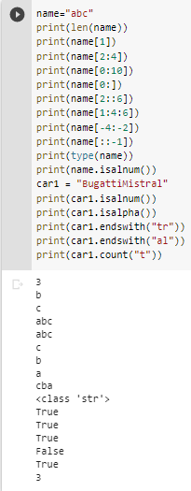

**C) BASIC ARRAY OPERATIONS ON 1-D AND MULTIDIMENSIONAL ARRAYS USING NUMPY**

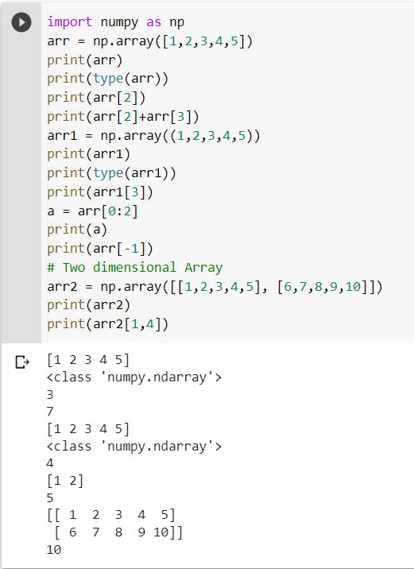

**D) IMPLEMENTING USER DEFINED AND ANONYMOUS FUNCTIONS**

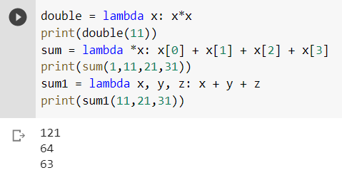

**Conclusion:** Thus we have studied and executed different List and Tuple operations, built-in Set and String functions, basic Array operations on 1-D and Multidimensional arrays using Numpy, Implementing User defined and Anonymous Functions.

**Shashwat Tripathi**

**D10A 58**

**BATCH: C**

**PYTHON LAB**

**Exp No: 3**

**AIM:** Write python programs to understand

A) Classes, Objects, Constructors, Inner class and Static method

B) Different types of Inheritance

C) Polymorphism using Operator overloading, Method overloading, Method

overriding in Python.

**A) CLASSES, OBJECTS, CONSTRUCTORS, INNER CLASS AND STATIC METHOD**

**CODE:**

**Class & Object**

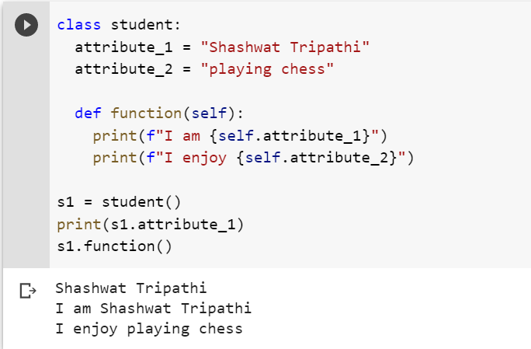

**Constructor**

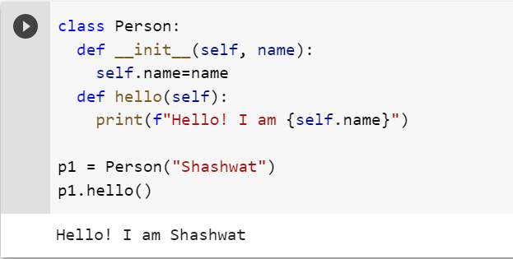

**INNER CLASS**

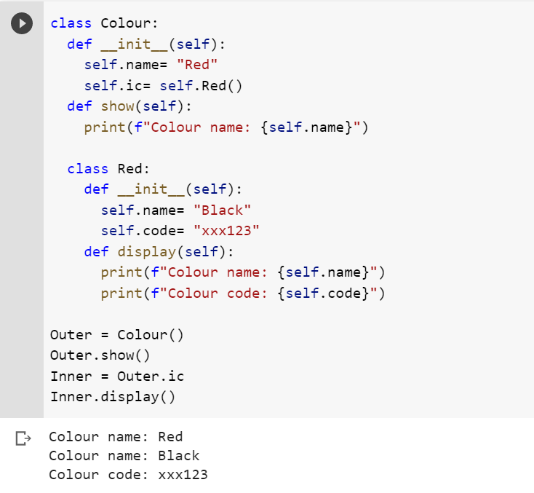

**B) DIFFERENT TYPES OF INHERITANCE**

**CODE:**

**SIMPLE INHERITANCE**

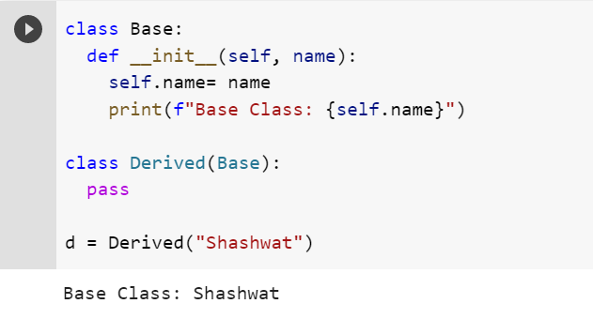

**MULTILEVEL**

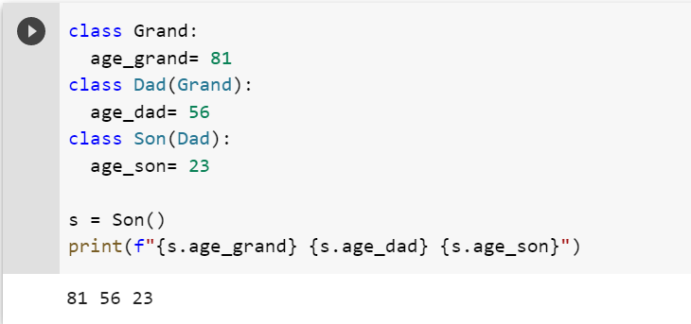

**MULTIPLE**

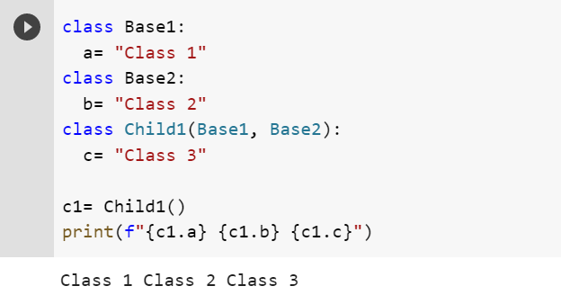

**HIERARCHICAL**

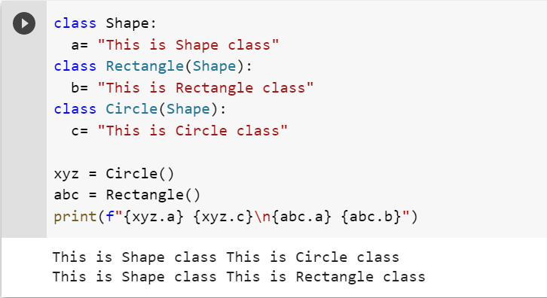

**C) POLYMORPHISM USING OPERATOR OVERLOADING,METHOD OVERLOADING,METHOD OVERRIDING,ABSTRACT CLASS,ABSTRACT METHOD AND INTERFACES**

**CODE:**

**OVERLOADING**

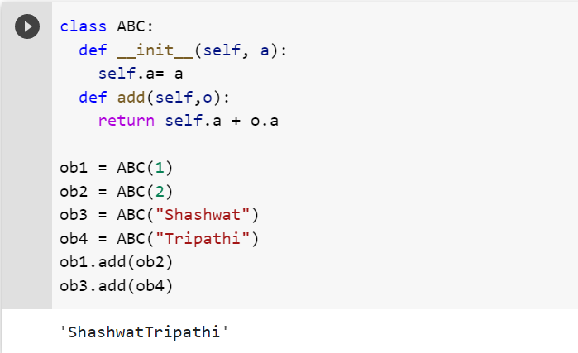

**METHOD OVERLOADING**

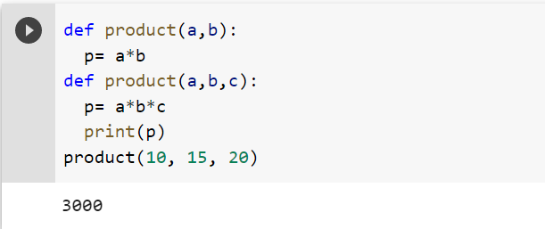

**METHOD OVERRIDING**

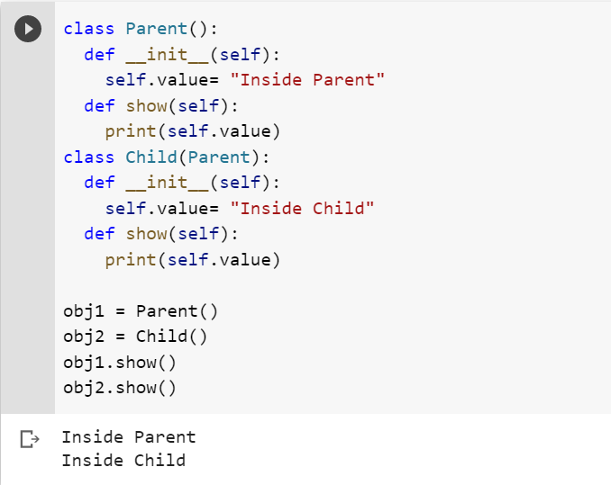

**ABSTRACT CLASS AND METHOD**

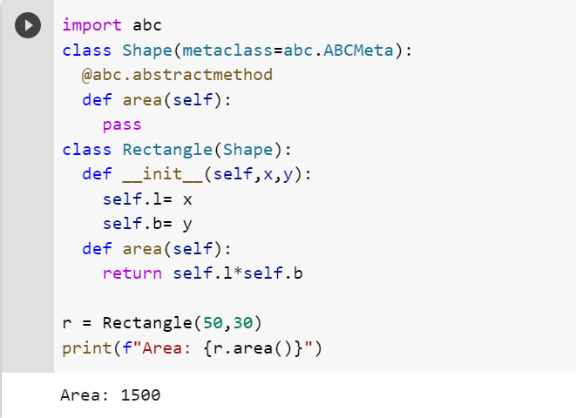

**INTERFACE**

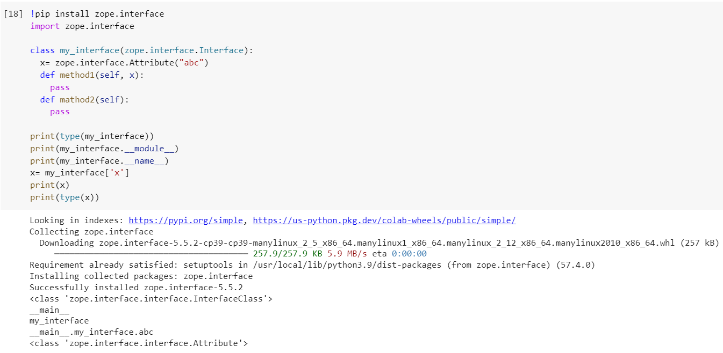

**Conclusion -** Concepts of object-oriented programming were learned and implemented.

**Shashwat Tripathi**

**D10A 58**

**BATCH: C**

**PYTHON LAB**

**Exp No: 4**

**AIM:** Write python programs to understand

a) Creating User-defined modules/packages and import them in a program.

b) Python program to illustrate the concept of threading importing the threading module.

c) Creating a menu driven application which should cover all the built-in exceptions in python.

**CODE:**

**Math Module**

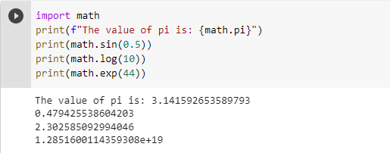

**OS Module**

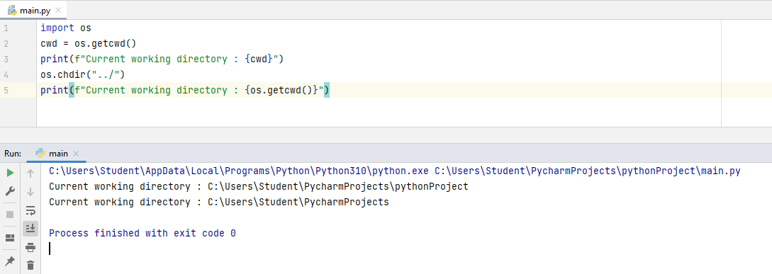

**SYS Module**

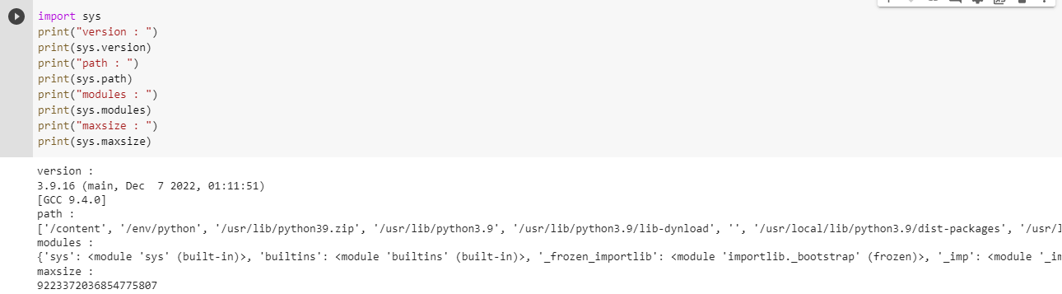

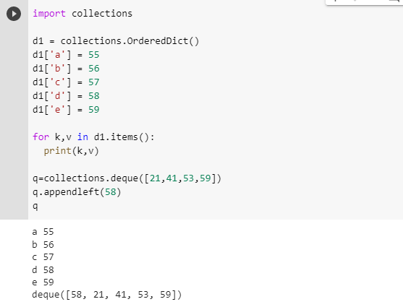

**Random Module**

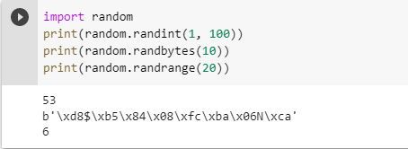

**Regular expression module**

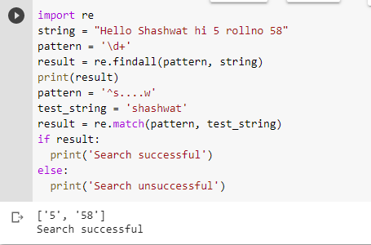

**Threading**

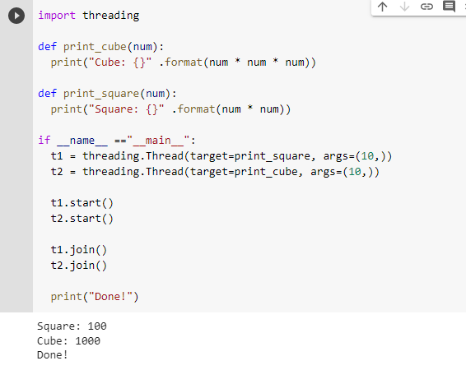

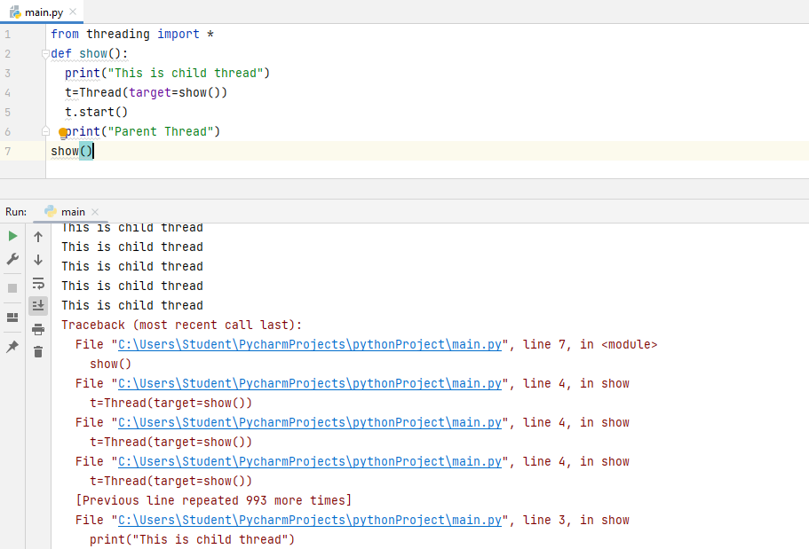

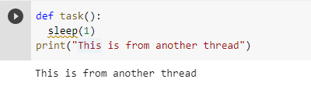

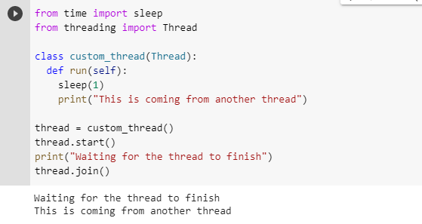

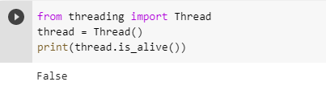

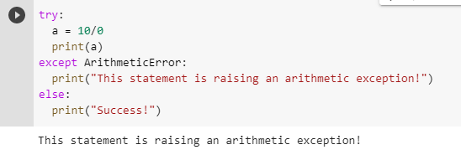

**Conclusion:** Thus we have created User-defined modules/packages and imported them in our program.

**Shashwat Tripathi**

**D10A 58**

**BATCH: C**

**PYTHON LAB**

**Exp No: 5**

**AIM:** 1. Demonstrate a python code to print try, except and finally block statements.

2. Demonstrate a python code to Compile time errors.

3. Demonstrate a python code to Run time errors.

**CODE:**

1. **Try,Except,Finally**

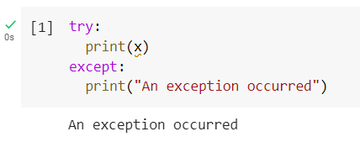

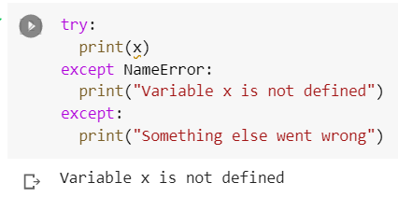

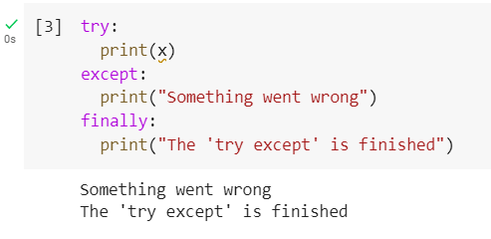

1. **Compile Time Errors**

Syntax Errors-

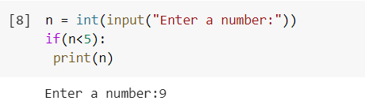

Semantics Errors-

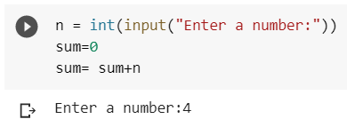

1. **Runtime Errors**

Logical error-

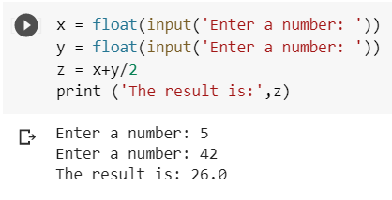

Index error-

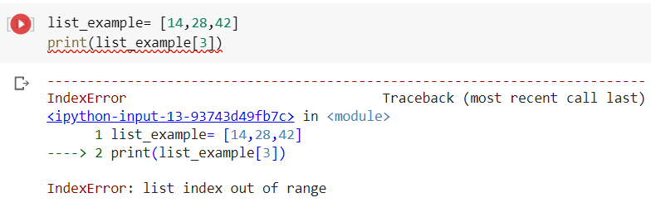

Module error-

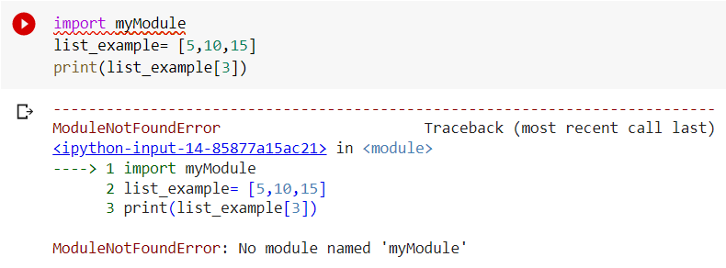

Value error-

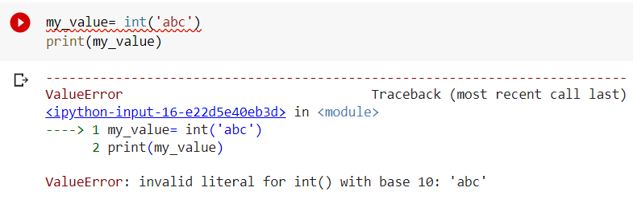

Divide by zero-

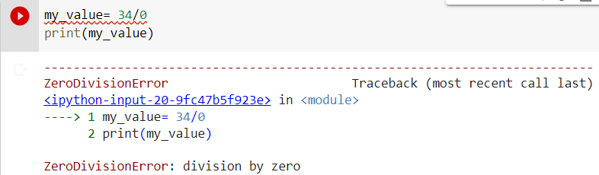

Name error-

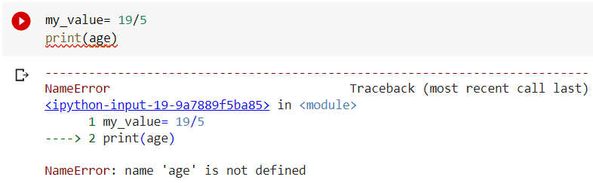

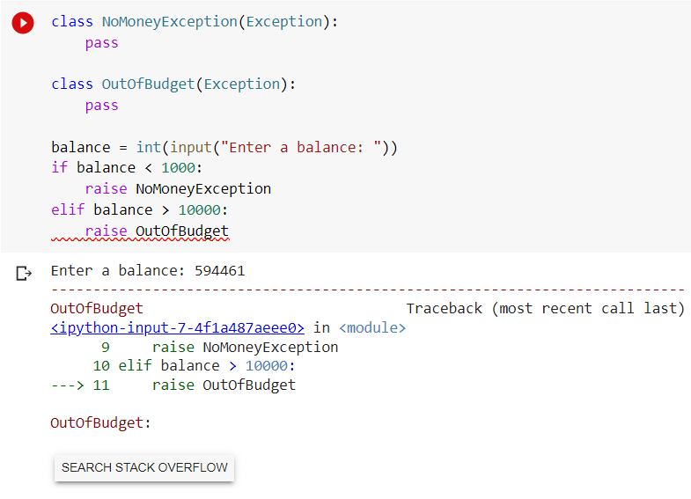

**Conclusion:** Thus the concepts of exception handling and errors were studied and implemented.